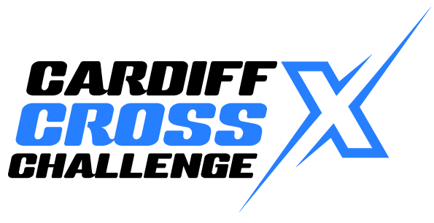

**CARDIFF: Saturday 16th October 2021**

**Prize money is as follows;**

Senior Men 1st £500.00  
Senior Men 2nd £200.00  
Senior Men 3rd £150.00  
Senior Men 4th £100.00

Senior Women 1st £500.00  
Senior Women 2nd £200.00  
Senior Women 3rd £150.00  
Senior Women 4th £100.00

A close up of a logo

Description generated with very high confidence

Junior Women 1st £250.00  
Junior Women 2nd £150.00  
Junior Women 3rd £100.00  
Junior Women 4th £50.00

Junior Men 1st £250.00  
Junior Men 2nd £150.00  
Junior Men 3rd £100.00  
Junior Men 4th £50.00

U17 Men & U17 Women 1st £70.00 plus BA Medal  
U17 Men & U17 Women 2nd £50.00 plus BA Medal

U17 Men & U17 Women 3rd £30.00 plus BA Medal

U17 Men & U17 Women 4th £20.00

U15 Boys & U15 Girls 1st £70.00 plus BA Medal

U15 Boys & U15 Girls 2nd £50.00 plus BA Medal

U15 Boys & U15 Girls 3rd £30.00 plus BA Medal

U15 Boys & U15 Girls 4th £20.00

U13 Boys & U13 Girls 1st £70.00 plus BA Medal   
U13 Boys & U13 Girls 2nd £50.00 plus BA Medal   
U13 Boys & U13 Girls 3rd £30.00 plus BA Medal   
U13 Boys & U13 Girls 4th £20.00

U11 Boys & U11 Girls 1st WA Medal  
U11 Boys & U11 Girls 2nd WA Medal  
U11 Boys & U11 Girls 3rd WA Medal

A close up of a logo

Description generated with high confidence